|  |  |  |
| --- | --- | --- |
| Pin 1 | Pin 2 | Output |
| 0 | 0 |  |
| 0 | 1 |  |
| 1 | 0 |  |
| 1 | 1 |  |

|  |  |
| --- | --- |
| Pin 1 | Outtro |
| 0 |  |
| 1 |  |

|  |  |  |
| --- | --- | --- |
| Pin 1 | Pin 2 | Outtro |
| 0 | 0 |  |
| 0 | 1 |  |
| 1 | 0 |  |
| 1 | 1 |  |

1. A logical expression that compares two binary inputs A and B and evaluate to true only if both A and B are the same is a led, a XNOR gate and pins connected to each input:

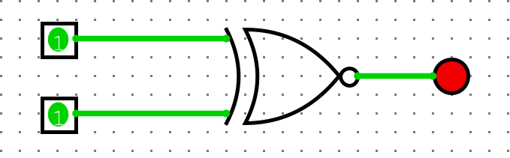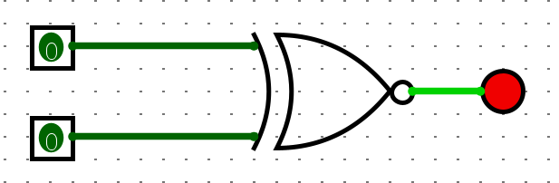

15.  
